Dosage method test report

DOC. No.: | REV.: 00 |  |  | PRODUCT: All SL machine
TITLE: Dosage method test report |  |  |  | Project:
Prepared by: | Lewis Chen |  |  | Date: | 2009.09.21
Remark: | Approval:
Remark: |  | Department | Title |  |  | Signature
Remark: | 1 | Electronic R&D
Remark: | 2
Remark: | 3
Remark: | 4

Revision | Description of Change | Author | Date
00 | Write this report | Lewis Chen | 2009.09.21
01 | Add resolvent about how to improve canister dosage method | Lewis Chen | 2009.10.09

1. Overview 4
1.1. Test purpose 4
1.2. Test environment 4
2. Process 4
2.1. Step1→ Compare test 4
2.2. Step2→Change test (environment two) 6
2.3. Step3→LPC2210 ADC characteristic test(environment two) 7
2.4. Step4→Sample speed test (environment two) 8
3. Conclusion 9
4. Solution 9
4.1. Solution one 9
4.2. Solution two 9
Appendix 9

Overview
This report record test process, test data and the conclusion of canister control method.

Test purpose
As we know, the canister control method is not very accurate always. To find out a method to improve the canister control, the test has been taken.

Test environment
Environment one:
SL 50 machine

Environment two:
Hardware: 75466 IO
Software: Guangzhou software platform
Mechanism: European canister (the same canister with environment one)

Process

Step1→ Compare test
In this compare test, different motor speeds have been used to dispense the same amount of powder.

Data in environment one:
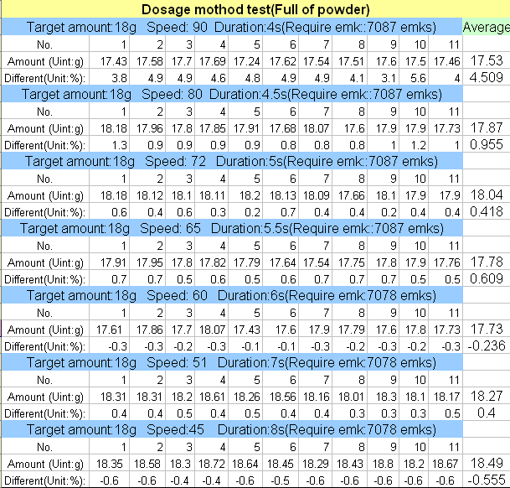

Data in environment two:
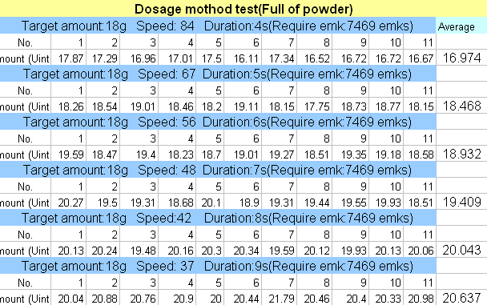

Conclusion:
As the duration become longer, the tolerance of amount become bigger, no mater in which environment.

PS: For more data, you can refer to our blog. Here is the link as follow:
http://10.10.0.45/blog/?p=91

Step2→Change test (environment two)
In Guangzhou code and Euro code the 24V power supply isn’t detected anymore. Assume that the control issue is cause by this change. So the change test has been taken.

Without detect 24V power supply:
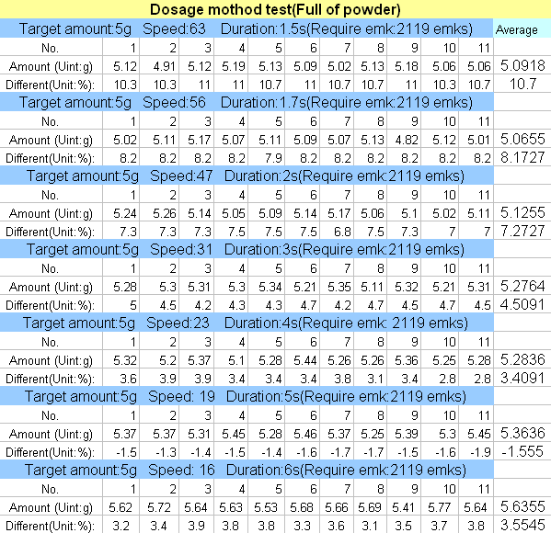

Detect 24V power supply:
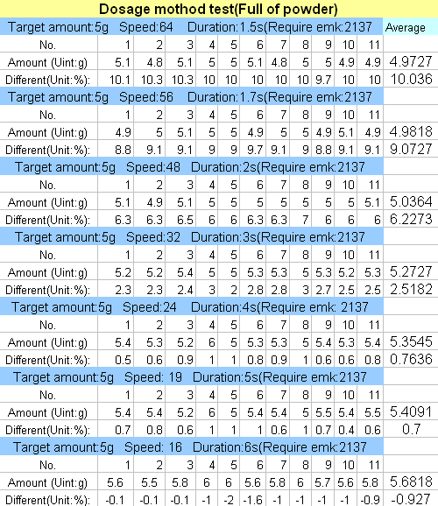

Conclusion:
No matter detect 24V power supply or not, the dosage control issue still exists. So the hardware cause can be ignored.

Step3→LPC2210 ADC characteristic test(environment two)
To make sure that the ADC characteristic is linear, the ADC characteristic test has taken.
Process:
Write a test code for this test, and then connect a power supply to LPC2210 ADC PIN directly. Change the voltage level, and then read the ADC feedback.

Voltage(V) | 0.58 | 0.68 | 0.78 | 0.88 | 0.98 | 1.08 | 1.18 | 1.28 | 1.38
sample | 47 | 54 | 63 | 70 | 78 | 84 | 92 | 100 | 109
Voltage(V) | 1.58 | 1.68 | 1.78 | 1.88 | 1.99 | 2.09 | 2.19 | 2.29 | 2.38
Sample | 126 | 134 | 142 | 151 | 157 | 165 | 175 | 182 | 187
Voltage(V) | 2.48 | 2.58 | 2.69 | 2.79 | 2.89 | 2.99 | 3.08 | 3.18
Sample | 197 | 205 | 214 | 221 | 227 | 237 | 242 | 253

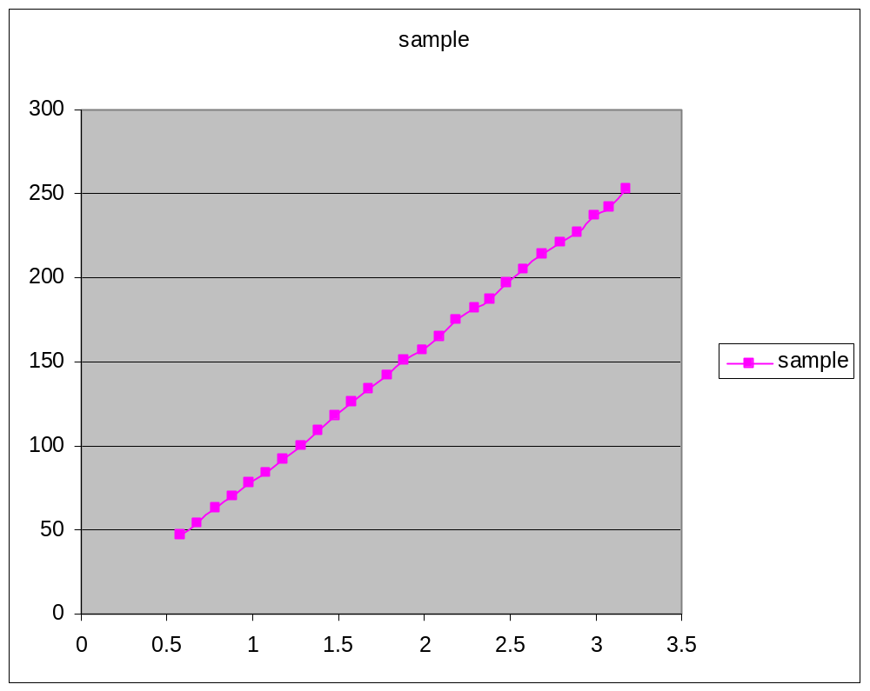
Conclusion:
The test result shows that the ADC characteristic is linear. So the hardware cause can be ignored.

Step4→Sample speed test (environment two)
Assume the dosage issue is caused by the capacitance delay characteristic. So the capacitance has been removed. Then sample the signal directly.
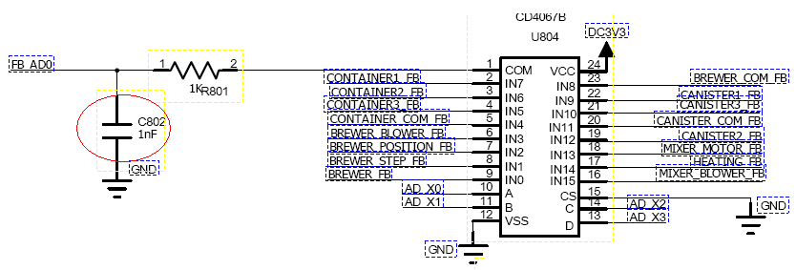
Conclusion:
After this test, it seems that the dosage issue has very little to deal with the capacitance characteristic.

Conclusion
The canister control arithmetic isn’t very accurate. Veracity will be influenced by the amount of powder in the canister, the mechanism of canister and the speed of canister motor. Because of all these factors will affect the EMK points that we got to control the motor. During the test, as the speed of canister motor become lower, the revolutions of canister motor tend to become more.

Solution

Solution one

Add motor coder
As the canister control issue is not only an arithmetic issue. If the veracity has to be improved, the coder has to be added to canister motor. With the help of coder, the revolutions of canister can be control.
Advantage: More accurate.
Disadvantage: Higher expense

Solution two

Improve arithmetic
As the BEMF of the motor is not linear, by adding a function which describes the character of BEMF, the dosage arithmetic can be improved.
Advantage: Cheaper.
Disadvantage: more complex

Here is a diagram which shows the relationship between revolution and motor speed, while dispense certain amount of powder.
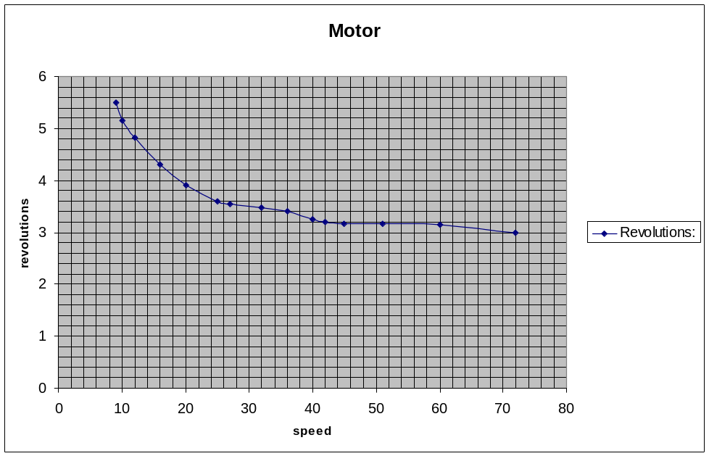
Revolutions-speed curve
According to this diagram, the BEMF is in non-linear direct proportion to motor speed. Then a revise function has been design to simulate this non-linear character.

Appendix

